**Worksheet 2.1.2**

**Student Name: Devansh Pandey UID: 21MCA2604**

**Branch: MCA Section/Group MCA5-B**

**Semester: 4 DateofPerformance: 04-04-2023**

**Subject Name: Embedded Programming Subject Code: 21CAH-752**

**1. Aim/Overview of the practical: (For Even UIDs)**

Interface an Arduino Uno with seven segment display**(Common Anode)** and two pushbuttons**(Pull UP)**. When we press the push button 1 it will print count 0 to 9 on display and after pressing button 2 it will print A to F on display.

**Note:**

1. **Paste the Screenshots of Every Circuit as per the mentioned case.**
2. **Screenshot should have your Name and UID (21MCI1234_XYZ)**
3. **Mention the comments in the programming.**

**2. Apparatus (For applied/experimental sciences/materials based labs):**

**Hardware Requirements**

**Software requirements**

**3. Circuit Diagram(TinkerCad):**

1. **Coding:**

int buttonState = 0;

int button1 = 0;

void setup()

{

pinMode(9, INPUT); //it initialize digital pin is input

pinMode(1, OUTPUT);//A and it initialize digital pin is output

pinMode(2, OUTPUT);//B and it initialize digital pin is output

pinMode(3, OUTPUT);//C and it initialize digital pin is output

pinMode(4, OUTPUT);//D and it initialize digital pin is output

pinMode(5, OUTPUT);//E and it initialize digital pin is output

pinMode(6, OUTPUT);//F and it initialize digital pin is output

pinMode(7, OUTPUT);//G and it initialize digital pin is output

pinMode(8, OUTPUT);//DP and it initialize digital pin is output

}

void loop()

{

buttonState = digitalRead(9);

button1 = digitalRead(12);

if(button1 == HIGH){

//A

digitalWrite(1, HIGH);//LED A, lights on

digitalWrite(2, HIGH);//LED B, lights on

digitalWrite(3, HIGH);//LED C, lights on

digitalWrite(4, LOW);//LED D, lights off

digitalWrite(5, HIGH);//LED E, lights on

digitalWrite(6, HIGH);//LED F, lights on

digitalWrite(7, HIGH);//LED G, lights on

digitalWrite(8, HIGH);//LED DP, lights on

delay(2000); // Wait for 2000 millisecond(s)

//B

digitalWrite(1, LOW);//LED A, lights off

digitalWrite(2, LOW);//LED B, lights off

digitalWrite(3, HIGH);//LED C, lights on

digitalWrite(4, HIGH);//LED D, lights on

digitalWrite(5, HIGH);//LED E, lights on

digitalWrite(6, HIGH);//LED F, lights on

digitalWrite(7, HIGH);//LED G, lights on

digitalWrite(8, HIGH);//LED DP, lights on

delay(2000); // Wait for 2000 millisecond(s)

//C

digitalWrite(1, HIGH);//LED A, lights on

digitalWrite(2, LOW);//LED B, lights off

digitalWrite(3, LOW);//LED C, lights off

digitalWrite(4, HIGH);//LED D, lights on

digitalWrite(5, HIGH);//LED E, lights on

digitalWrite(6, HIGH);//LED F, lights on

digitalWrite(7, LOW);//LED G, lights off

digitalWrite(8, HIGH);//LED DP, lights on

delay(2000); // Wait for 2000 millisecond(s)

//D

digitalWrite(1, LOW);//LED A, lights on

digitalWrite(2, HIGH);//LED B, lights on

digitalWrite(3, HIGH);//LED C, lights on

digitalWrite(4, HIGH);//LED D, lights on

digitalWrite(5, HIGH);//LED E, lights on

digitalWrite(6, LOW);//LED F, lights off

digitalWrite(7, HIGH);//LED G, lights on

digitalWrite(8, HIGH);//LED DP, lights on

delay(2000); // Wait for 2000 millisecond(s)

//E

digitalWrite(1, HIGH);//LED A, lights on

digitalWrite(2, LOW);//LED B, lights off

digitalWrite(3, LOW);//LED C, lights off

digitalWrite(4, HIGH);//LED D, lights on

digitalWrite(5, HIGH);//LED E, lights on

digitalWrite(6, HIGH);//LED F, lights on

digitalWrite(7, HIGH);//LED G, lights on

digitalWrite(8, HIGH);//LED DP, lights on

delay(2000); // Wait for 2000 millisecond(s)

//F

digitalWrite(1, HIGH);//LED A, lights on

digitalWrite(2, LOW);//LED B, lights off

digitalWrite(3, LOW);//LED C, lights off

digitalWrite(4, LOW);//LED D, lights off

digitalWrite(5, HIGH);//LED E, lights on

digitalWrite(6, HIGH);//LED F, lights on

digitalWrite(7, HIGH);//LED G, lights on

digitalWrite(8, HIGH);//LED DP, lights on

delay(2000); // Wait for 2000 millisecond(s)

}else{

digitalWrite(1, LOW);//LED A, lights off

digitalWrite(2, LOW);//LED B, lights off

digitalWrite(3, LOW);//LED C, lights off

digitalWrite(4, LOW);//LED D, lights off

digitalWrite(5, LOW);//LED E, lights off

digitalWrite(6, LOW);//LED F, lights off

digitalWrite(7, LOW);//LED G, lights off

digitalWrite(9, LOW);//LED DP, lights off

}

if (buttonState == HIGH) {

//it will read pin 9

// zero//the no. expected to display in 7 segment display

digitalWrite(1, HIGH);//LED A, lights on

digitalWrite(2, HIGH);//LED B, lights on

digitalWrite(3, HIGH);//LED C, lights on

digitalWrite(4, HIGH);//LED D, lights on

digitalWrite(5, HIGH);//LED E, lights on

digitalWrite(6, HIGH);//LED F, lights on

digitalWrite(7, LOW);//LED G, lights off

digitalWrite(8, LOW);//LED DP, lights off

delay(2000); // Wait for 2000 millisecond(s)

// 1 //the no. expected to display in 7 segment display

digitalWrite(1, LOW);//LED A, lights off

digitalWrite(2, HIGH);//LED B, lights on

digitalWrite(3, HIGH);//LED C, lights on

digitalWrite(4, LOW);//LED D, lights off

digitalWrite(5, LOW);//LED E, lights off

digitalWrite(6, LOW);//LED F, lights off

digitalWrite(7, LOW);//LED G, lights off

digitalWrite(8, LOW);//LED DP, lights off

delay(2000); // Wait for 2000 millisecond(s)

// 2 //the no. expected to display in 7 segment display

digitalWrite(1, HIGH);//LED A, lights on

digitalWrite(2, HIGH);//LED B, lights on

digitalWrite(3, LOW);//LED C, lights off

digitalWrite(4, HIGH);//LED D, lights on

digitalWrite(5, HIGH);//LED E, lights on

digitalWrite(6, LOW);//LED F, lights off

digitalWrite(7, HIGH);//LED G, lights on

digitalWrite(8, LOW);//LED DP, lights off

delay(2000); // Wait for 2000 millisecond(s)

// 3 //the no. expected to display in 7 segment display

digitalWrite(1, HIGH);//LED A, lights on

digitalWrite(2, HIGH);//LED B, lights on

digitalWrite(3, HIGH);//LED C, lights on

digitalWrite(4, HIGH);//LED D, lights on

digitalWrite(5, LOW);//LED E, lights off

digitalWrite(6, LOW);//LED F, lights off

digitalWrite(7, HIGH);//LED G, lights on

digitalWrite(8, LOW);//LED DP, lights off

delay(2000); // Wait for 2000 millisecond(s)

// 4 //the no. expected to display in 7 segment display

digitalWrite(1, LOW);//LED A, lights off

digitalWrite(2, HIGH);//LED B, lights on

digitalWrite(3, HIGH);//LED C, lights on

digitalWrite(4, LOW);//LED D, lights off

digitalWrite(5, LOW);//LED E, lights off

digitalWrite(6, HIGH);//LED F, lights on

digitalWrite(7, HIGH);//LED G, lights on

digitalWrite(8, LOW);//LED DP, lights off

delay(2000); // Wait for 2000 millisecond(s)

// 5 //the no. expected to display in 7 segment display

digitalWrite(1, HIGH);//LED A, lights on

digitalWrite(2, LOW);//LED B, lights off

digitalWrite(3, HIGH);//LED C, lights on

digitalWrite(4, HIGH);//LED D, lights on

digitalWrite(5, LOW);//LED E, lights off

digitalWrite(6, HIGH);//LED F, lights on

digitalWrite(7, HIGH);//LED G, lights on

digitalWrite(8, LOW);//LED DP, lights off

delay(2000); // Wait for 2000 millisecond(s)

// 6 //the no. expected to display in 7 segment display

digitalWrite(1, HIGH);//LED A, lights on

digitalWrite(2, LOW);//LED B, lights off

digitalWrite(3, HIGH);//LED C, lights on

digitalWrite(4, HIGH);//LED D, lights on

digitalWrite(5, HIGH);//LED E, lights on

digitalWrite(6, HIGH);//LED F, lights on

digitalWrite(7, HIGH);//LED G, lights on

digitalWrite(8, LOW);//LED DP, lights off

delay(2000); // Wait for 2000 millisecond(s)

// 7 //the no. expected to display in 7 segment display

digitalWrite(1, HIGH);//LED A, lights on

digitalWrite(2, HIGH);//LED B, lights on

digitalWrite(3, HIGH);//LED C, lights on

digitalWrite(4, LOW);//LED D, lights off

digitalWrite(5, LOW);//LED E, lights off

digitalWrite(6, LOW);//LED F, lights off

digitalWrite(7, LOW);//LED G, lights off

digitalWrite(8, LOW);//LED DP, lights off

delay(2000); // Wait for 2000 millisecond(s)

// 8 //the no. expected to display in 7 segment display

digitalWrite(1, HIGH);//LED A, lights on

digitalWrite(3, HIGH);//LED B, lights on

digitalWrite(3, HIGH);//LED C, lights on

digitalWrite(4, HIGH);//LED D, lights on

digitalWrite(5, HIGH);//LED E, lights on

digitalWrite(6, HIGH);//LED F, lights on

digitalWrite(7, HIGH);//LED G, lights on

digitalWrite(9, LOW);//LED DP, lights off

delay(2000); // Wait for 2000 millisecond(s)

// 9 //the no. expected to display in 7 segment display

digitalWrite(1, HIGH);//LED A, lights on

digitalWrite(2, HIGH);//LED B, lights on

digitalWrite(3, HIGH);//LED C, lights on

digitalWrite(4, HIGH);//LED D, lights on

digitalWrite(5, LOW);//LED E, lights off

digitalWrite(6, HIGH);//LED F, lights on

digitalWrite(7, HIGH);//LED G, lights on

digitalWrite(8, LOW);//LED DP, lights off

delay(2000); // Wait for 2000 millisecond(s)

} else {

digitalWrite(1, LOW);//LED A, lights off

digitalWrite(2, LOW);//LED B, lights off

digitalWrite(3, LOW);//LED C, lights off

digitalWrite(4, LOW);//LED D, lights off

digitalWrite(5, LOW);//LED E, lights off

digitalWrite(6, LOW);//LED F, lights off

digitalWrite(7, LOW);//LED G, lights off

digitalWrite(9, LOW);//LED DP, lights off

}

}

**OUTPUT-1**

**When we press the push button 1 it will print count 0 to 9 on display**

**Screenshort-1**

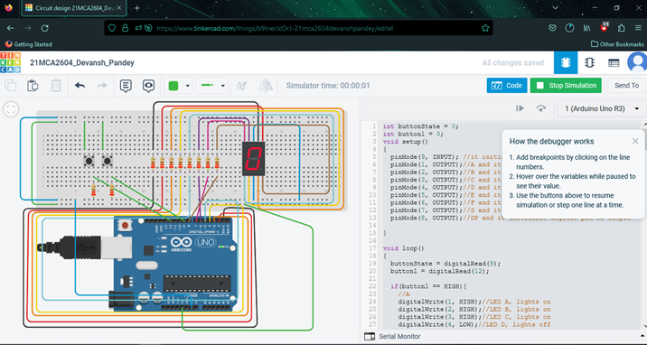

**Screenshort-2**

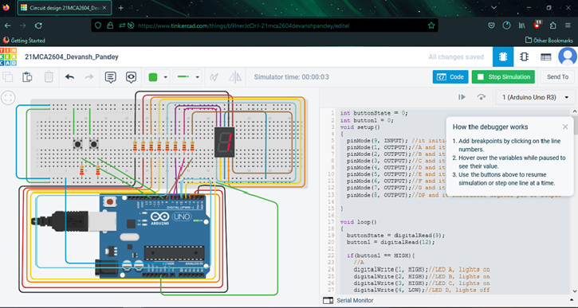

**Screenshort-3**

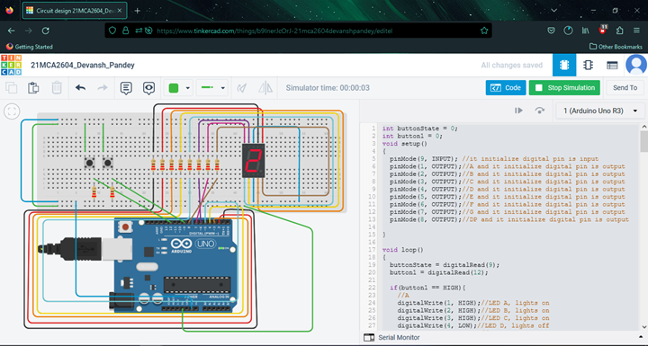

**Screenshort-4**

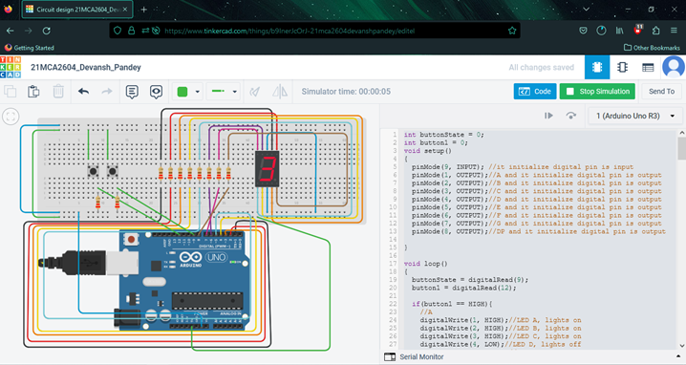

**Screenshort-5**

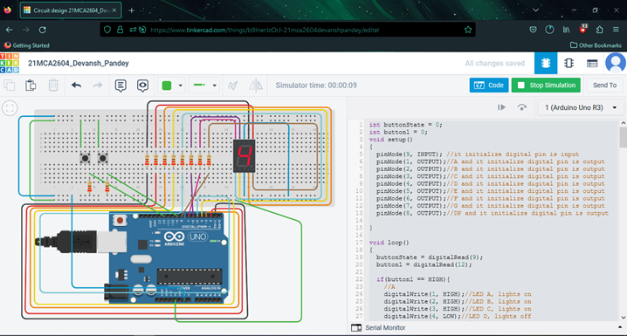

**Screenshort-6**

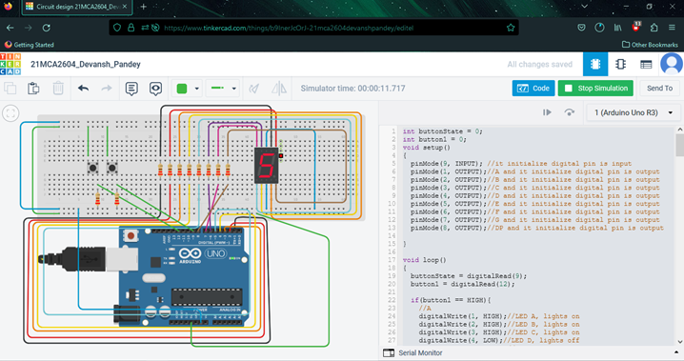

**Screenshort-7**

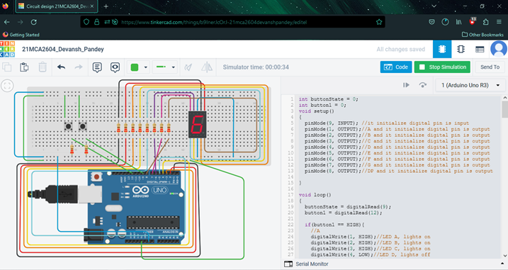

**Screenshort-8**

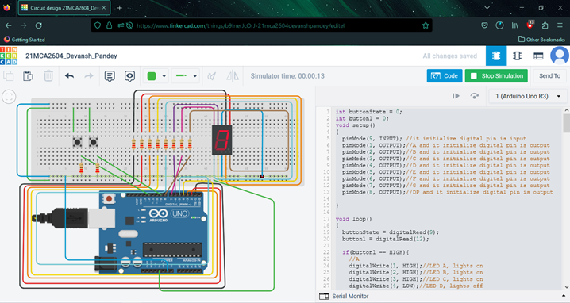

**Screenshort-9**

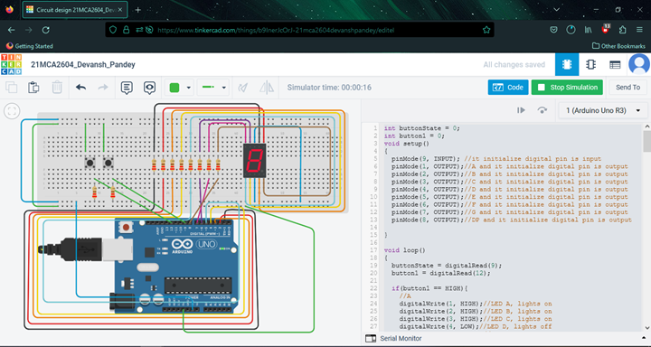

**Screenshort-10**

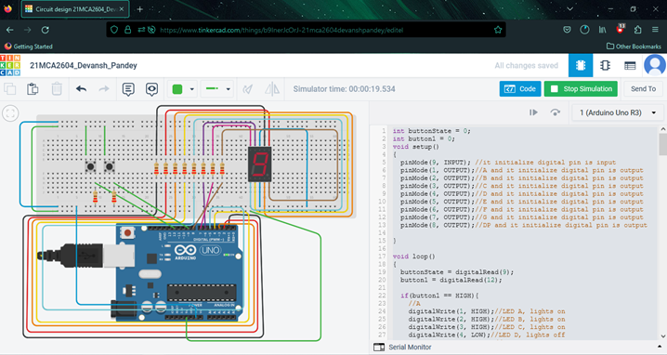

**OUTPUT-2**

**Pressing button 2 it will print A to F on display**

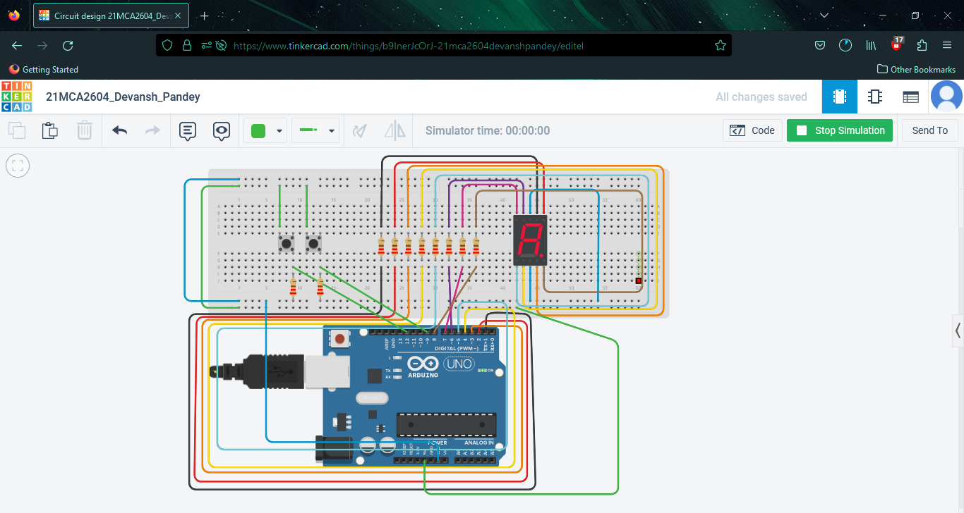

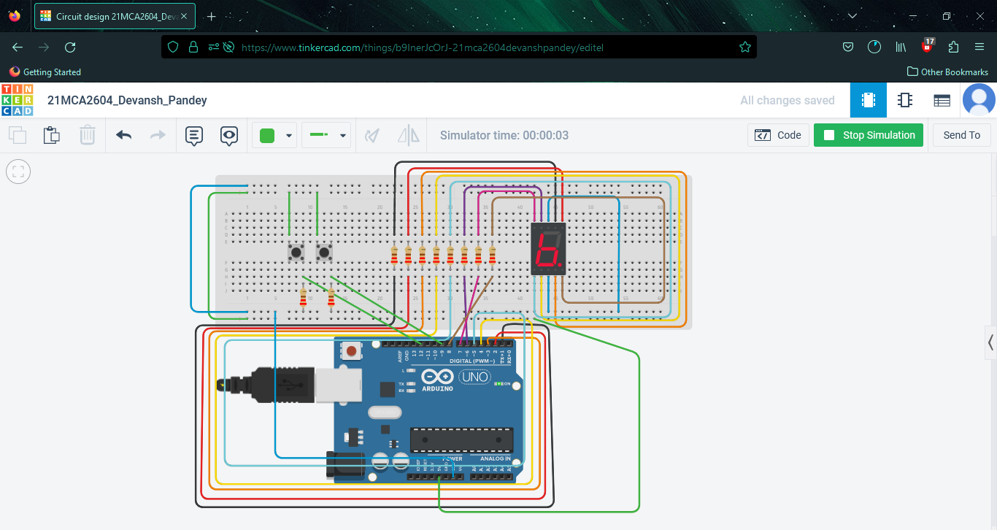

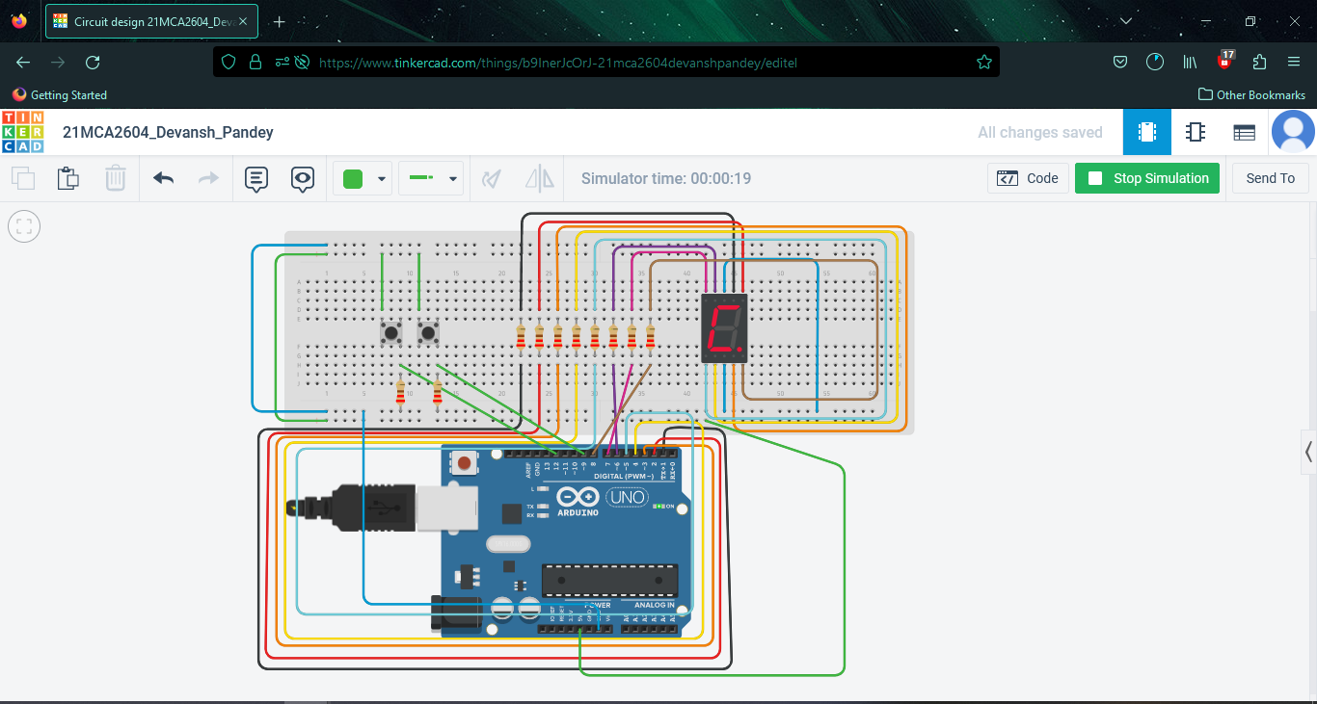

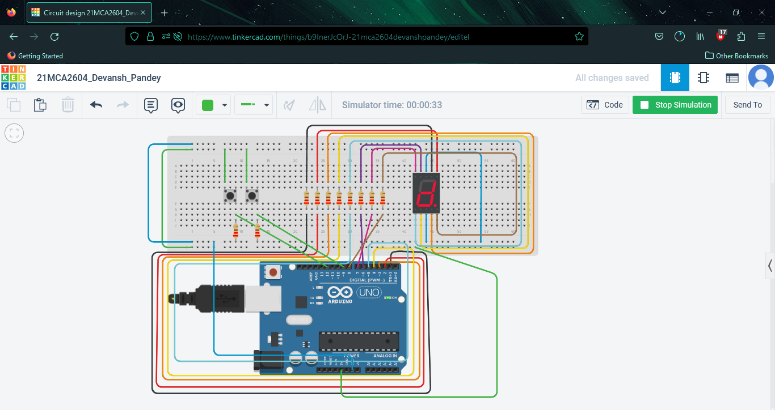

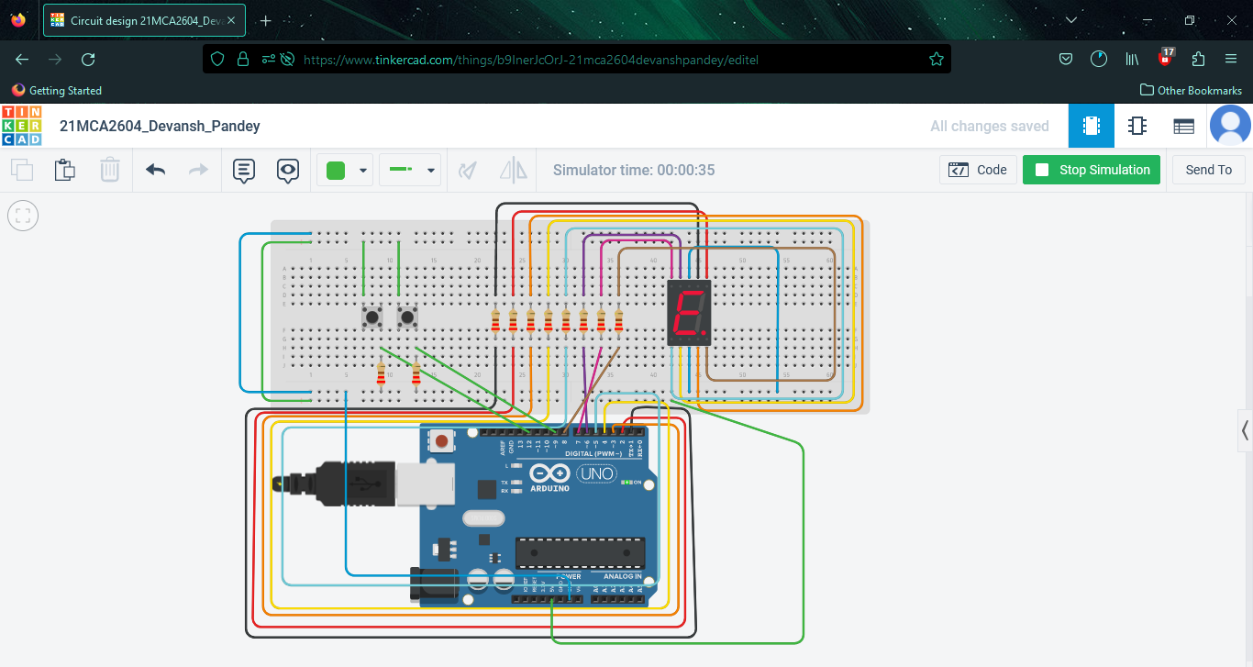

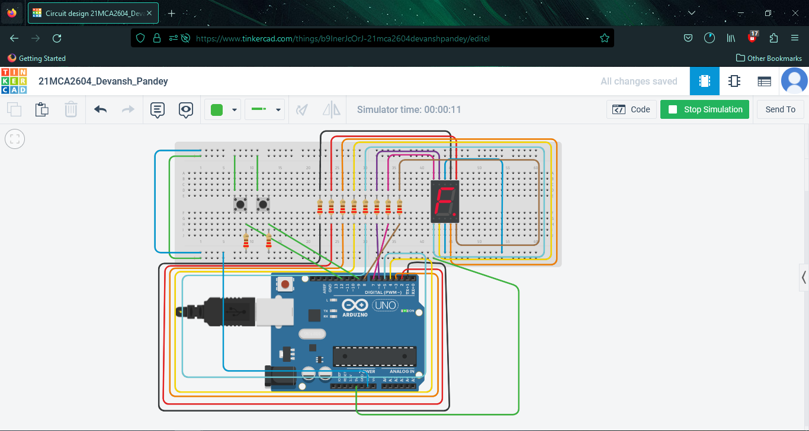

**Evaluation Grid (To be created as per the SOP and Assessment guidelines by the faculty):**

|  |  |  |  |
| --- | --- | --- | --- |
| Sr. No. | Parameters | Marks Obtained | Maximum Marks |
| 1. | Worksheet Completion |  | 10 marks |
| 2. | Post Lab Quiz Result |  | 5 marks |
| 3. | Student Engagement  (Simulation/ Demonstrate/Performance and Pre-Lab Questions)) |  | 5 marks |
|  | Total |  | 20 marks |